Vmesto Microsoft Word 12.0 postavity Microsoft Word 11.0 !

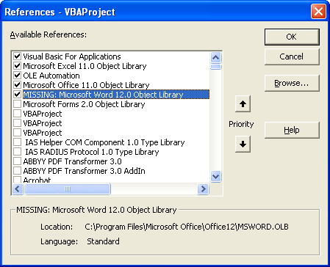

Office 11 Object Libbary - \program Files\Common|MS share\office11\mso.dll
Word 11 Object Libbary - \program Files\MS Offce\office11\msword.olb

Word 12 Object Libbary - \program Files\MS Offce\office12\msword.olb

